Lab 7 (ABC Airline UI Design)
Student ID: 101566625
Last Name:
Fist Name: Garv
CRN: 50313
Professor: Gurm

Wireframe 1
Name: Passenger Login Page
Image:
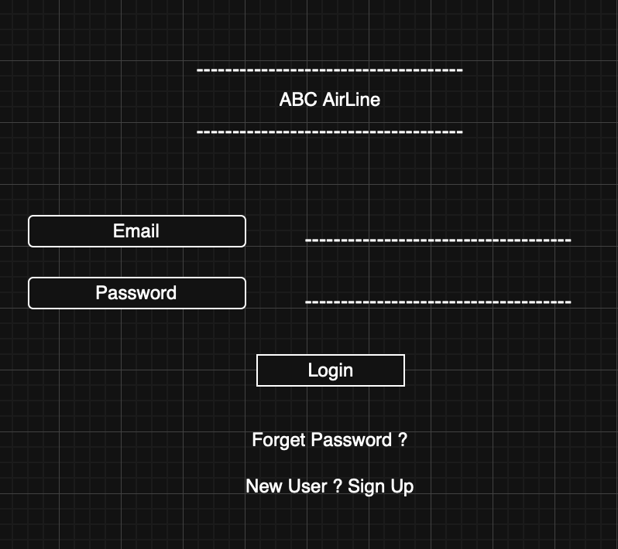
Wireframe 2
Name: Flight Booking Page
Image:
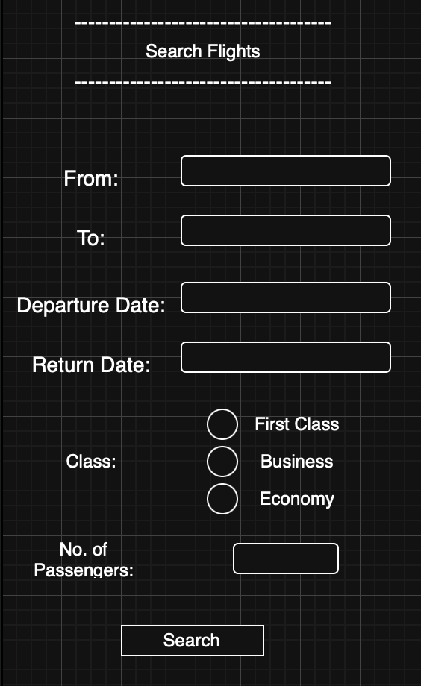
Wireframe 3
Name: Seat Selection + Check-in
Image:
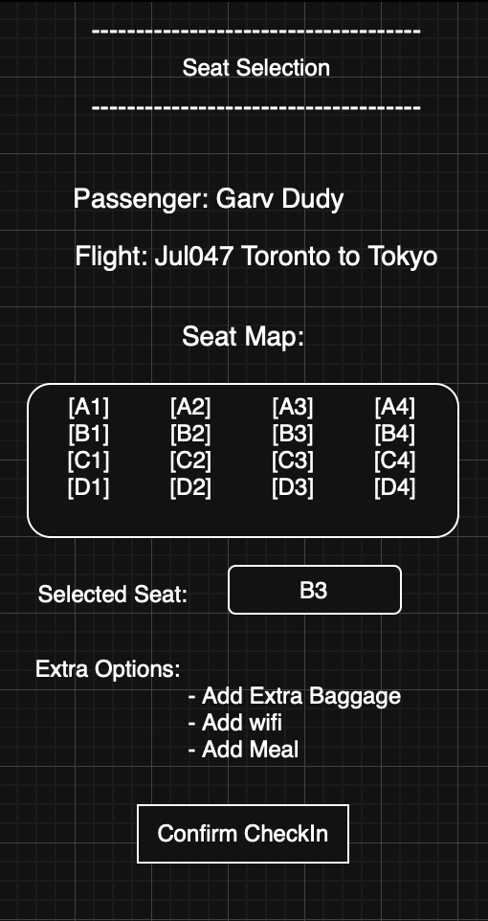
Wireframe 4
Name: Airline Staff log-in
Image:
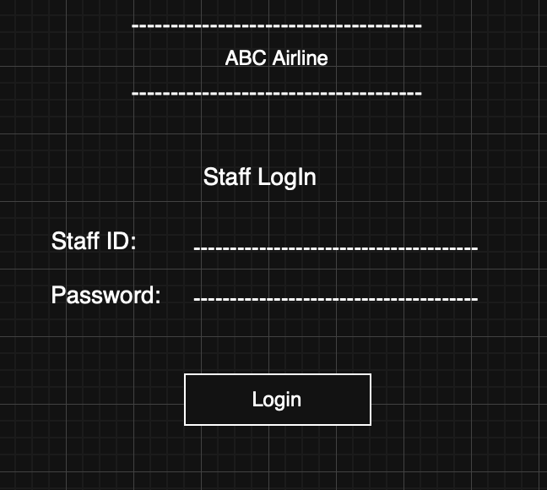
Wireframe 5
Name: Passenger Check-in Management
Image:
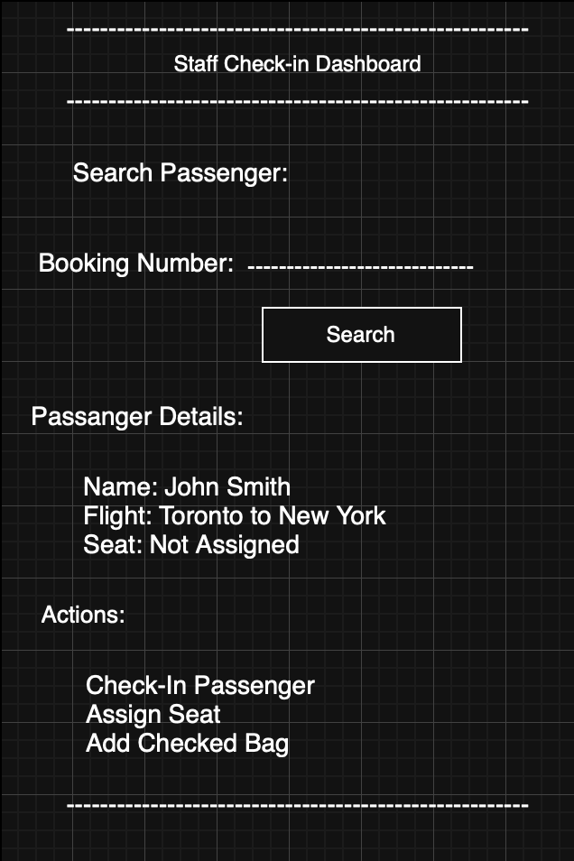
Wireframe6
Name: Manager Control Pannel
Image:
